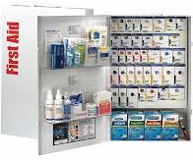
Dalton State College First Aid Kit Locations
First aid kits contain basic first aid supplies such as: band aids, burn ointment, antiseptic wipes, gauze, adhesive tape, etc.
Health Professions- Public Safety Office
Health Professions- Nursing, lower level Room #116
Loberbaum Hall- Room 277
Gignilliat Hall- Entrance Hallway across from Auditorium, 1st Floor Hallway North End of Building
Westcott Hall- Business Office (Break Room)
Westcott Hall- Enrollment Services (Break Room)
Pope Student Center- Dean of Students Office #226
Pope Student Center- Bookstore (Stockroom)
Pope Student Center- Cafeteria (Employee Area)
Pope Student Center- Beside Card Services #121
Sequoya Hall- Beside Rooms 139, 239, 209, 121
Plant Operations- Break room
Bandy Gym- First Aid Supplies Located in First Aid Room
Derrell Roberts Library- Behind Circulation Desk
Mashburn Hall- Office
Brown Hall Building- Kitchen, Main Entrance Hallway
Gilmer Center- Main Office, Biology Lab
Peeples Hall- Each level in the hallways (3)

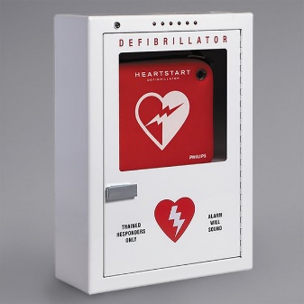
Dalton State College AED Locations
An automated external defibrillator (AED) is a portable electronic device that automatically diagnoses life-threatening cardiac arrhythmias and is able to treat them through the application of electricity which stops the arrhythmia, allowing the heart to reestablish an effective rhythm. Training to operate an AED is not required but suggested to increase operator confidence.
Bandy Gym- Outside First Aid Room on Lower Level
Sequoya Hall- Lower Hallway beside Rm #139
Derrell Roberts Library- Lower level mounted on column next to front desk
Westcott Hall- Inside Business Office Lobby
Pope Student Center- Outside Eddie Miller Room #201
Loberbaum Hall- Outside Room 277 (Break room 2nd Floor)
Gignilliat Hall- Hallway Across from Auditorium Entrance
Health Professions- Hallway (next to Room #309)
Brown Hall- Main Entrance Lobby
Plant Operations- Outside Room #153
Mashburn Hall- Office
Peeples Hall- Second level, East end of hallway
Ottinger Hall- Second level, north side of building
Gilmer Center- Inside main offices

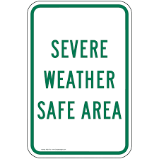
Weather Safe Areas
Dalton State does not have specifically designed buildings with weather safe areas but designates safer areas of refuge in buildings. It is important to move to a lower level of the building away from glass doors and windows, preferably on the interior of the building. In hallways, it is important to close all classroom doors for more protection from glass breakage. For more information, please contact the Public Safety Department at 706-272-4461.
Bandy Gym- Men’s and Women’s Locker Rooms
Sequoya Hall- Stairwells on South End of Building. Lecture Room First Floor
Derrell Roberts Library- Middle Stairwell and interior rooms without glass.
Westcott Hall- Area Around Safe in Business Office. Kitchen area and hallway in Enrollment Services.
Gignilliat Hall- Both East and West Interior Hallways (close classroom doors).
Loberbaum Hall- Both East and West 1st floor Hallways (close classroom doors).
Pope Student Center- Rooms against Back Wall on Lower Level, Restrooms on Lower Level.
Health Professions- Nursing area (offices) downstairs on the north end of the building.
Brown Hall- Lower Level Hallway and adjacent maintenance rooms, Large Conference Room also has Protective Film Over the Windows.
Ottinger Hall- Lower level, physical fitness area.
Peeples Hall- Lower level, designated lecture rooms.
Mashburn Hall- Lower level hallway, designated by signage

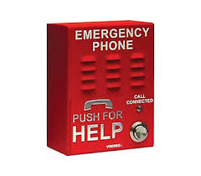
Building Emergency Phone Locations
Brown Hall 1st Floor- Beside room #108
Brown Hall 2nd Floor- Beside Elevator
Brown Hall 3rd Floor- Beside Elevator
Health Professions- Nursing Instruction Hallway (Mid Level)
Health Professions- Lower Level Entrance Beside #105
Bandy Gym- Upper Level Lobby
Derrell Roberts Library 1st Floor- Across From Front desk
Derrell Roberts Library 2nd Floor- Beside Office #232 Mashburn Hall 1st- Both Ends of the Hallway
Sequoya Hall 1st Floor- Hallway Beside #134 Mashburn Hall 2nd- Both Ends of the Hallway
Sequoya Hall 2nd Floor- Hallway Beside #219 and #208 Mashburn Hall 3rd- Both Ends of the Hallway
Pope Student Center- Beside Office 104 Mashburn Hall 4th- Both Ends of the Hallway
Gignilliat Hall North 1st- Beside Custodial Closet
Gignilliat Hall North 2nd- Beside #217
Gignilliat Hall 1st- Beside #104
Gignilliat Hall 2nd- Across Form #224
Loberbaum Hall 1st Floor- Hallway Across From Office #107
Loberbaum Hall 2nd Floor- Hallway Beside #237
Loberbaum Hall 3rd Floor- Hallway Beside #312
Ottinger Hall- Beside Office #104
Peeples Hall 1st Floor- East Entrance Beside Café
Peeples Hall 2nd Floor- East Entrance Beside #214
Peeples Hall 3rd Floor- East Entrance Beside #312
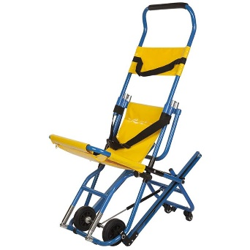
Evacuation Chair Locations
Brown Hall- Upper Level, Top of Stairs
Health Professions-Top of Stairs at Main (Nursing) Entrance
Loberbaum Hall- 2nd Level Top of Stairs
Mashburn Hall-Upper Level
Gignilliat Hall- South Upper Level Top of Stairs
Derrell Roberts Library- Upper Level Beside Elevator
Peeples Hall- 3rd level next to East Side Stairs
Sequoya Hall- Upper Level Beside Elevator

